AWS STATIC RESUME HOSTING
S3 + Amazon CloudFront + Origin Access Control
Project Report
Project | Static Resume / Portfolio Website Hosting
Cloud Services | Amazon S3, Amazon CloudFront
Security | Private S3 bucket + CloudFront Origin Access Control (OAC)
Region | S3 bucket in ap-south-1; CloudFront global distribution

1. Project Overview
This project demonstrates hosting a static resume website on AWS using Amazon S3 as a private origin and Amazon CloudFront as the public content-delivery layer. The website consists of HTML and CSS files. CloudFront provides HTTPS delivery and caching, while Origin Access Control (OAC) allows CloudFront to retrieve objects from S3 without making the bucket public.

2. Objectives
- Host a static HTML/CSS resume on AWS.
- Store website files in Amazon S3.
- Keep the S3 bucket private.
- Use CloudFront as the public delivery layer.
- Secure S3 access with CloudFront OAC.
- Serve the website through HTTPS.
- Gain practical experience with AWS storage, CDN and resource policies.

3. Architecture
The final request path is:
Browser → HTTPS → CloudFront → OAC / Private Access → S3
├── index.html
└── style.css
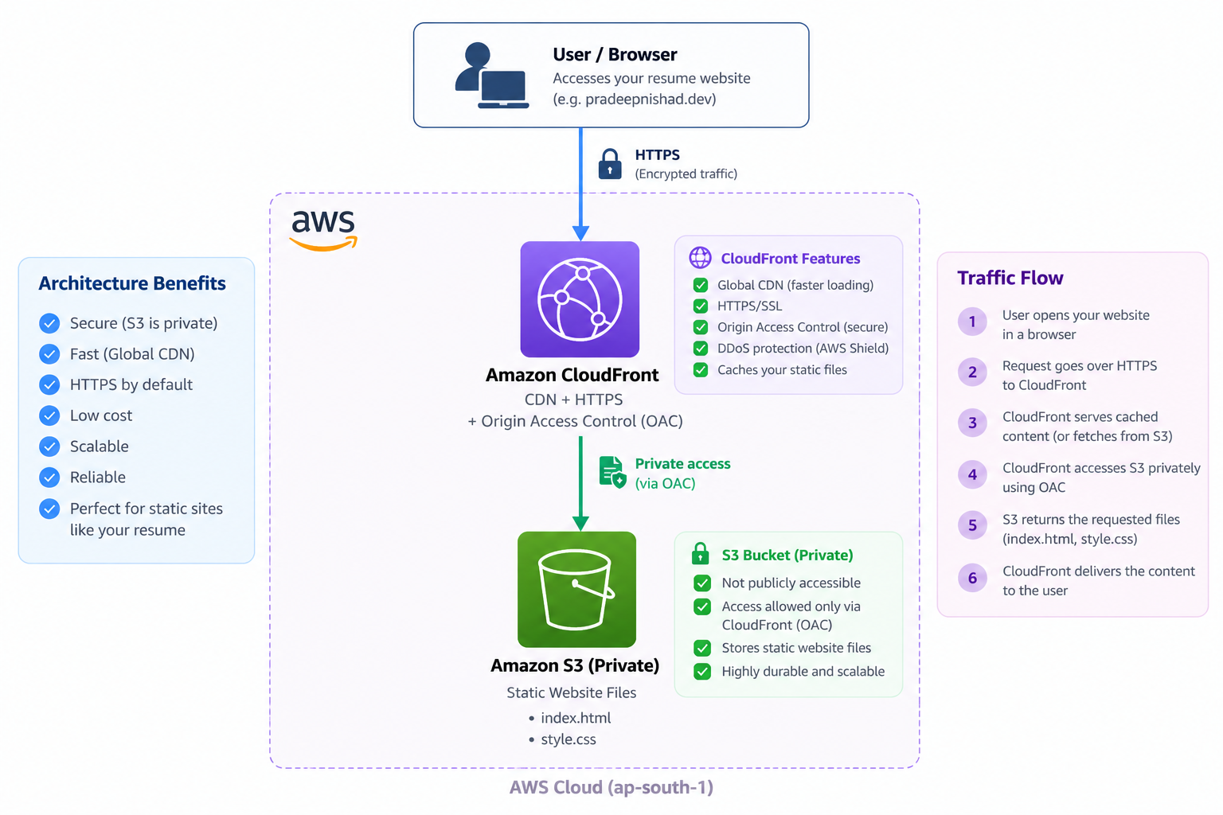
Figure 1. AWS static resume hosting architecture.

4. AWS Services
Service | Purpose | Configuration
Amazon S3 | Stores static files | Private bucket with index.html and style.css
Amazon CloudFront | CDN and public entry point | S3 origin with recommended cache settings
Origin Access Control | Secures CloudFront-to-S3 access | CloudFront service principal + distribution restriction
HTTPS | Encrypts browser traffic | CloudFront HTTPS endpoint

5. Implementation

Step 1 — Create the S3 Bucket
An S3 bucket named pradeep-resume-2026 was created. Public access was not enabled.
- Bucket name: pradeep-resume-2026
- Block Public Access: enabled
- ACLs: disabled
- Bucket kept private

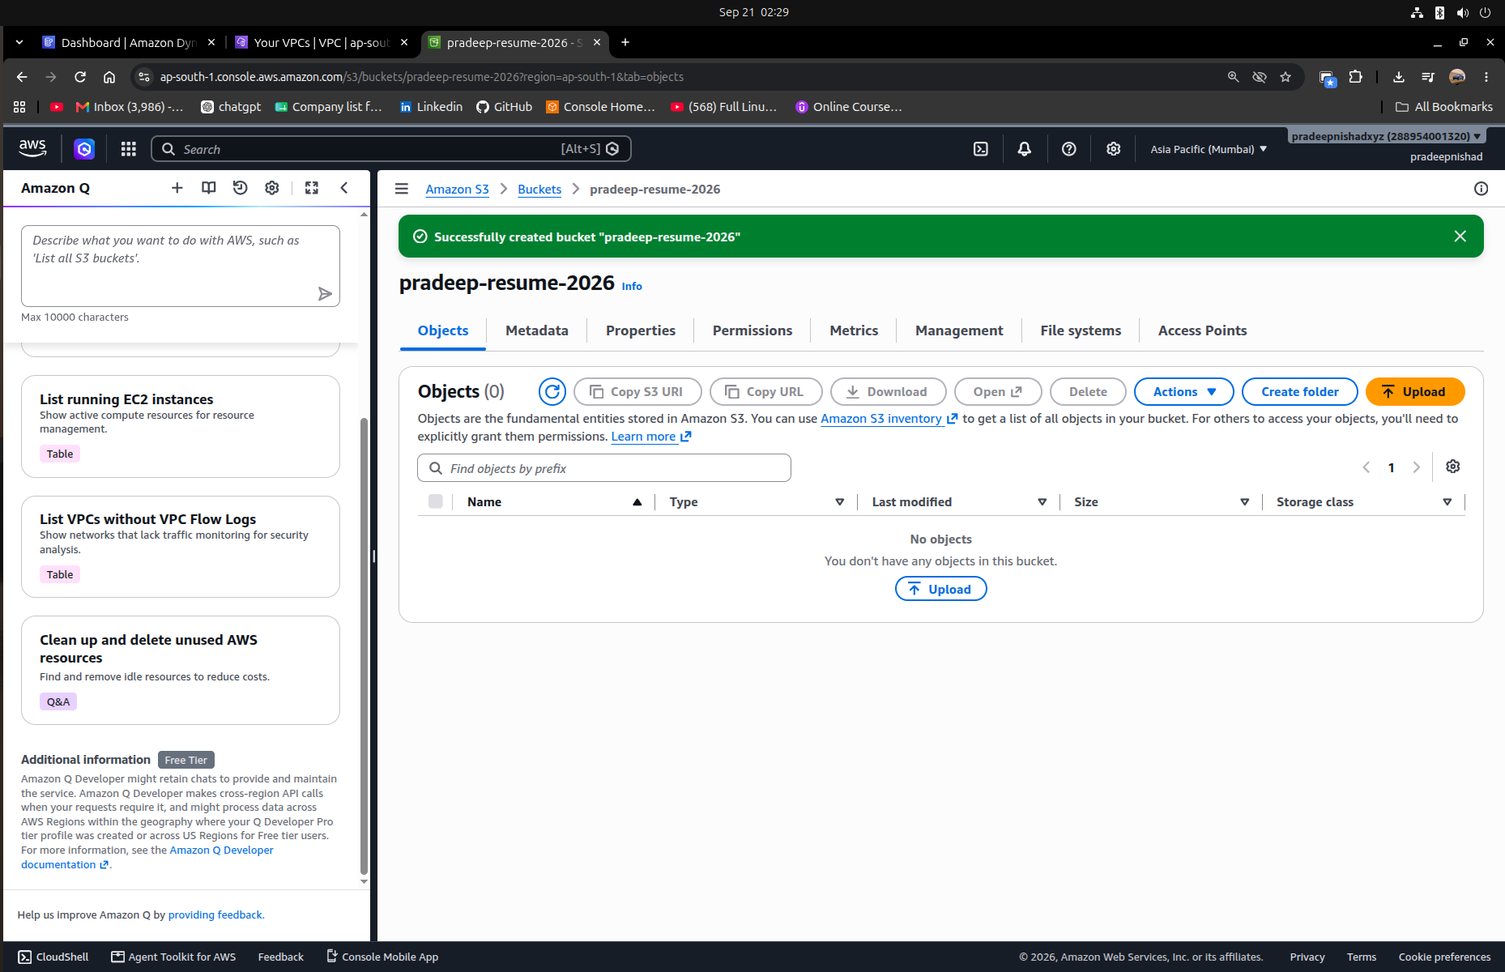

Step 2 — Upload Website Files
The following files were uploaded directly to the bucket root:
- index.html — main resume webpage
- style.css — styling, responsive layout and animations
S3 structure:
pradeep-resume-2026/
├── index.html
└── style.css
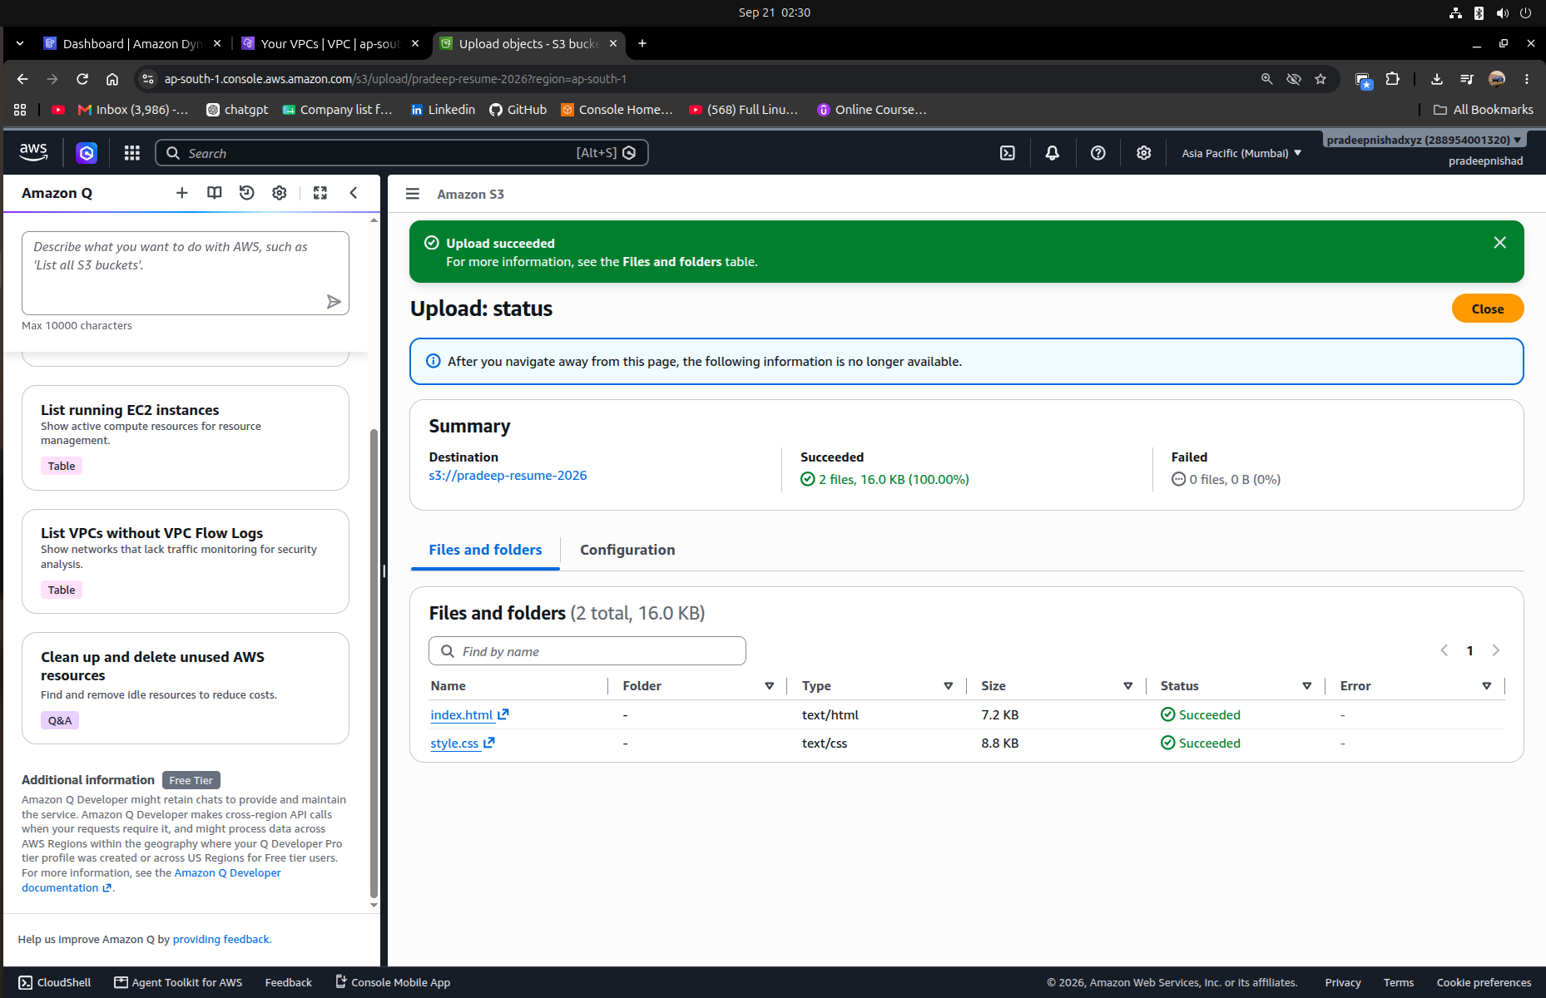

Step 3 — Create CloudFront Distribution
A CloudFront distribution was created using the S3 bucket as its origin. The recommended S3 origin and cache settings were selected.
- Origin: pradeep-resume-2026.s3.ap-south-1.amazonaws.com
- Origin path: empty
- Private S3 access through CloudFront: enabled
- Origin Access Control (OAC): enabled
- Recommended S3 cache settings: enabled
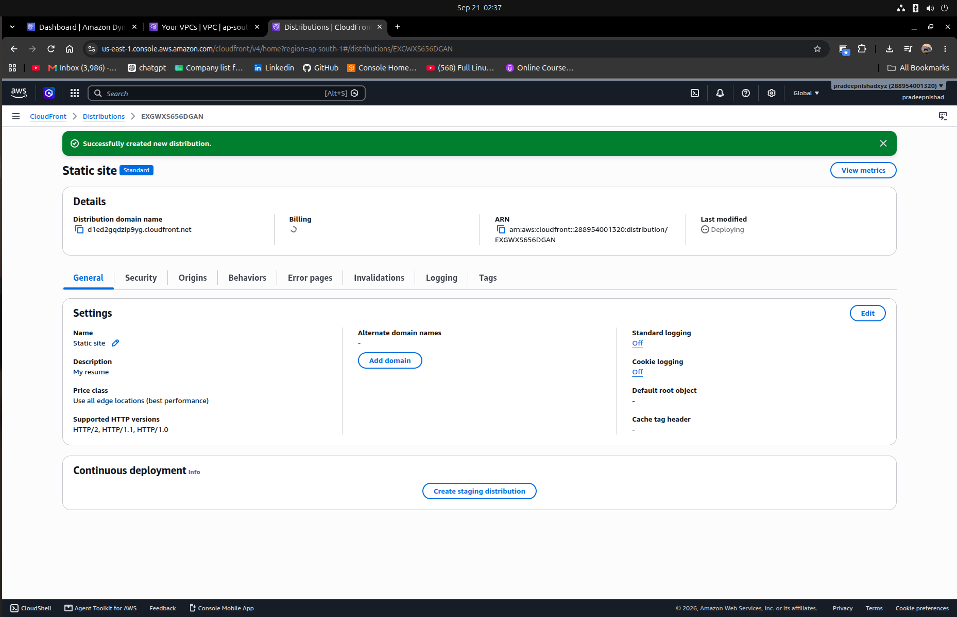

Step 4 — Configure Default Root Object
The default root object is configured as index.html. Therefore, a request to the CloudFront root URL can automatically serve the resume page.
Default root object: index.html

Step 5 — S3 Bucket Policy
CloudFront was granted read access to objects in the private S3 bucket. The policy restricts access to the CloudFront service principal and the specific distribution.
{
"Version": "2012-10-17",
"Statement": [{
"Sid": "AllowCloudFrontServicePrincipal",
"Effect": "Allow",
"Principal": {"Service": "cloudfront.amazonaws.com"},
"Action": "s3:GetObject",
"Resource": "arn:aws:s3:::pradeep-resume-2026/*",
"Condition": {
"StringEquals": {
"AWS:SourceArn": "arn:aws:cloudfront::288954001320:distribution/EXGWXS656DGAN"
}
}
}]
}
The /* suffix is important because s3:GetObject applies to objects inside the bucket. The SourceArn condition restricts the permission to the specified CloudFront distribution.
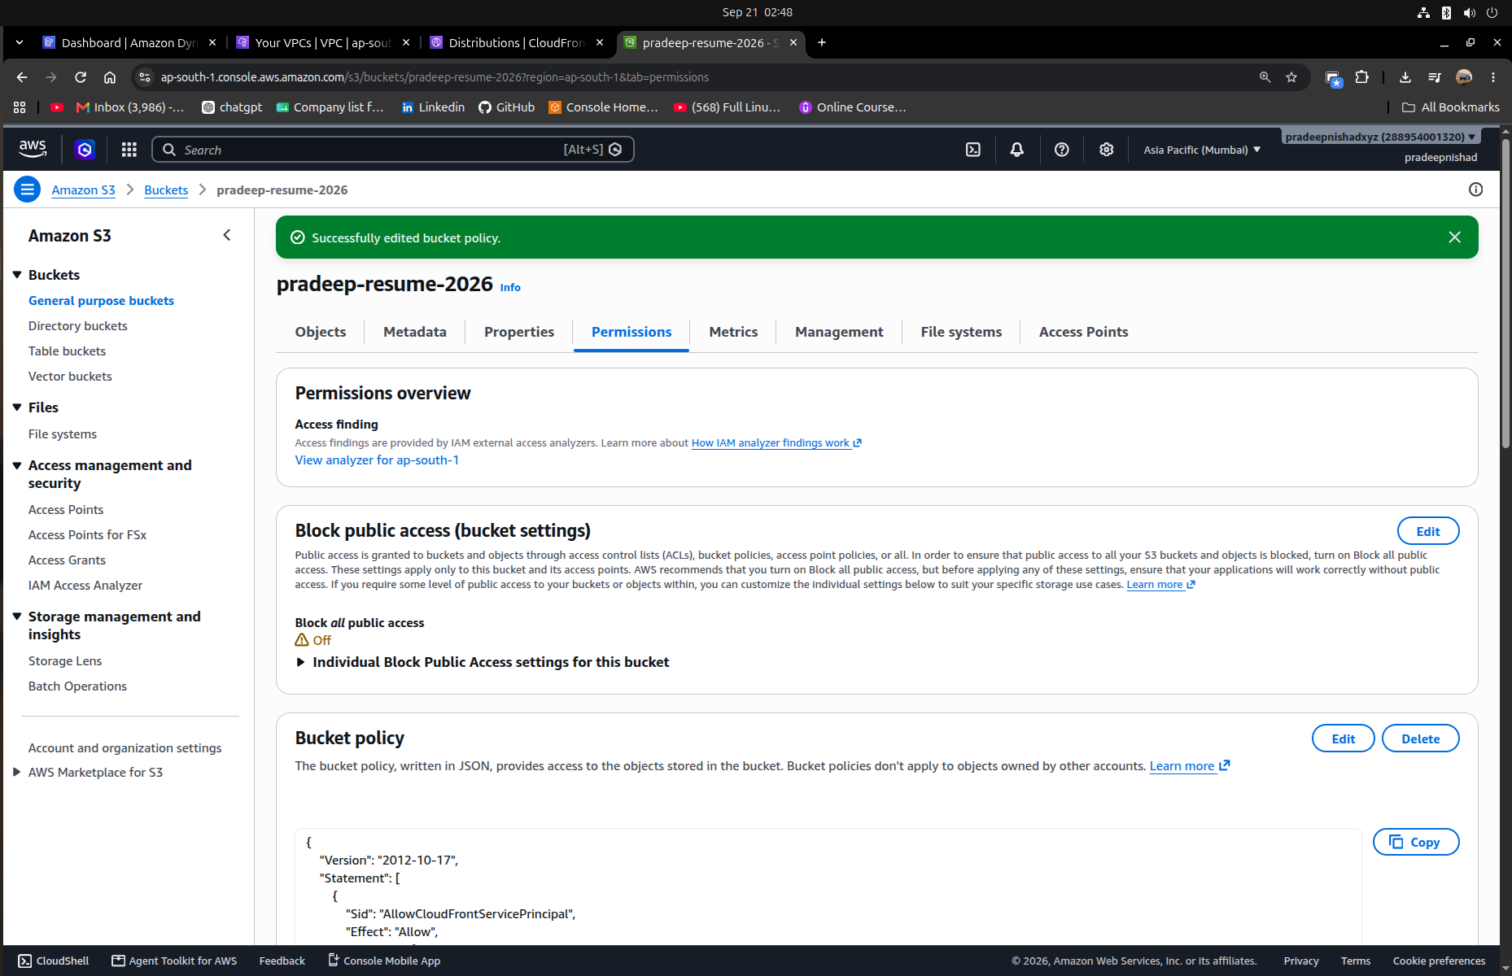

Step 6 - Deployment and Testing
After creation, CloudFront enters deployment. Once the distribution becomes enabled, the CloudFront distribution domain name can be opened over HTTPS.
- Distribution ID: EXGWXS656DGAN
- CloudFront URL: <CloudFront distribution domain name>
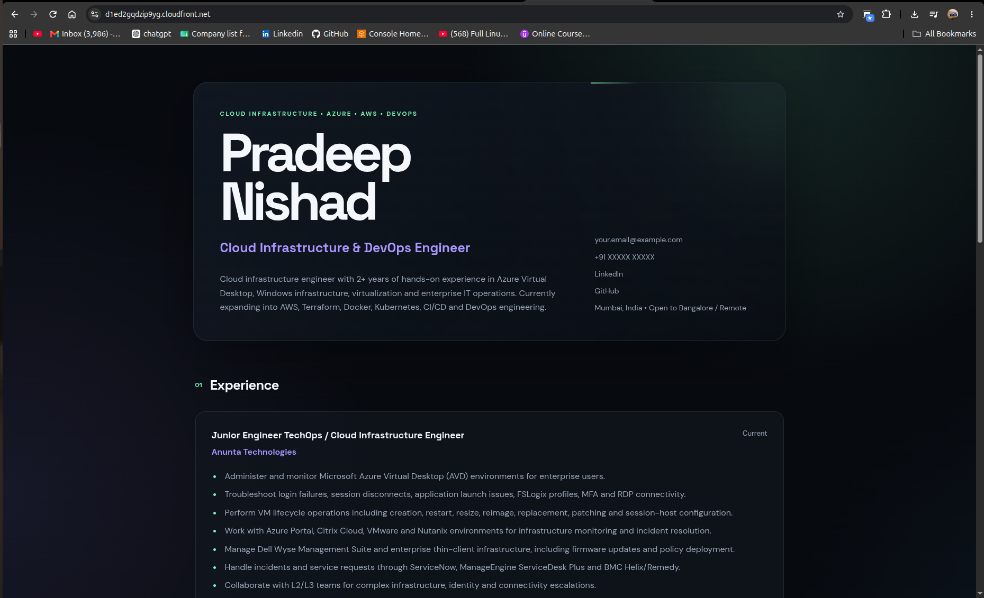

6. Security Design
- S3 remains private.
- S3 Block Public Access remains enabled.
- CloudFront uses OAC to authenticate to S3.
- The bucket policy grants only s3:GetObject.
- The policy is restricted to the specific CloudFront distribution.
- Browser traffic is delivered over HTTPS.

7. Request Flow
- User opens the CloudFront URL.
- Browser sends an HTTPS request to CloudFront.
- CloudFront checks its cache.
- If needed, CloudFront retrieves the object from S3 using OAC.
- S3 validates the bucket policy and returns the object.
- CloudFront delivers the content to the browser and may cache it for later requests.

8. Why This Architecture
Requirement | AWS design
Static files | Amazon S3
Public website endpoint | Amazon CloudFront
Private origin | S3 Block Public Access
Origin authentication | CloudFront OAC
HTTPS delivery | CloudFront
Caching / global delivery | CloudFront CDN

9. Testing Checklist
- ☐ S3 bucket contains index.html and style.css.
- ☐ S3 public access is blocked.
- ☐ CloudFront distribution is enabled.
- ☐ CloudFront can access S3 through OAC.
- ☐ Default root object is index.html.
- ☐ CloudFront URL loads the resume over HTTPS.
- ☐ CSS styling loads correctly.
- ☐ Direct public S3 access is not required.

10. Cost Considerations
The project uses AWS pay-as-you-go services. Actual cost depends on storage, requests and data transfer. AWS WAF was not enabled for this project, avoiding its additional configuration and charges.

11. Skills Demonstrated
- Amazon S3
- Amazon CloudFront
- Origin Access Control (OAC)
- S3 bucket policies
- HTTPS content delivery
- CDN and caching concepts
- Static website deployment
- AWS architecture and troubleshooting

12. Conclusion
The project demonstrates a secure and practical architecture for hosting a static resume website on AWS. S3 provides durable object storage while CloudFront provides the public HTTPS delivery layer. OAC allows CloudFront to access the private S3 origin without exposing the bucket directly to the internet. The project provides hands-on experience relevant to cloud infrastructure and DevOps engineering.

